Carrer Market Analyzer

Suraj Doddi

Creating Instance

Git Bash the folder that contains the key

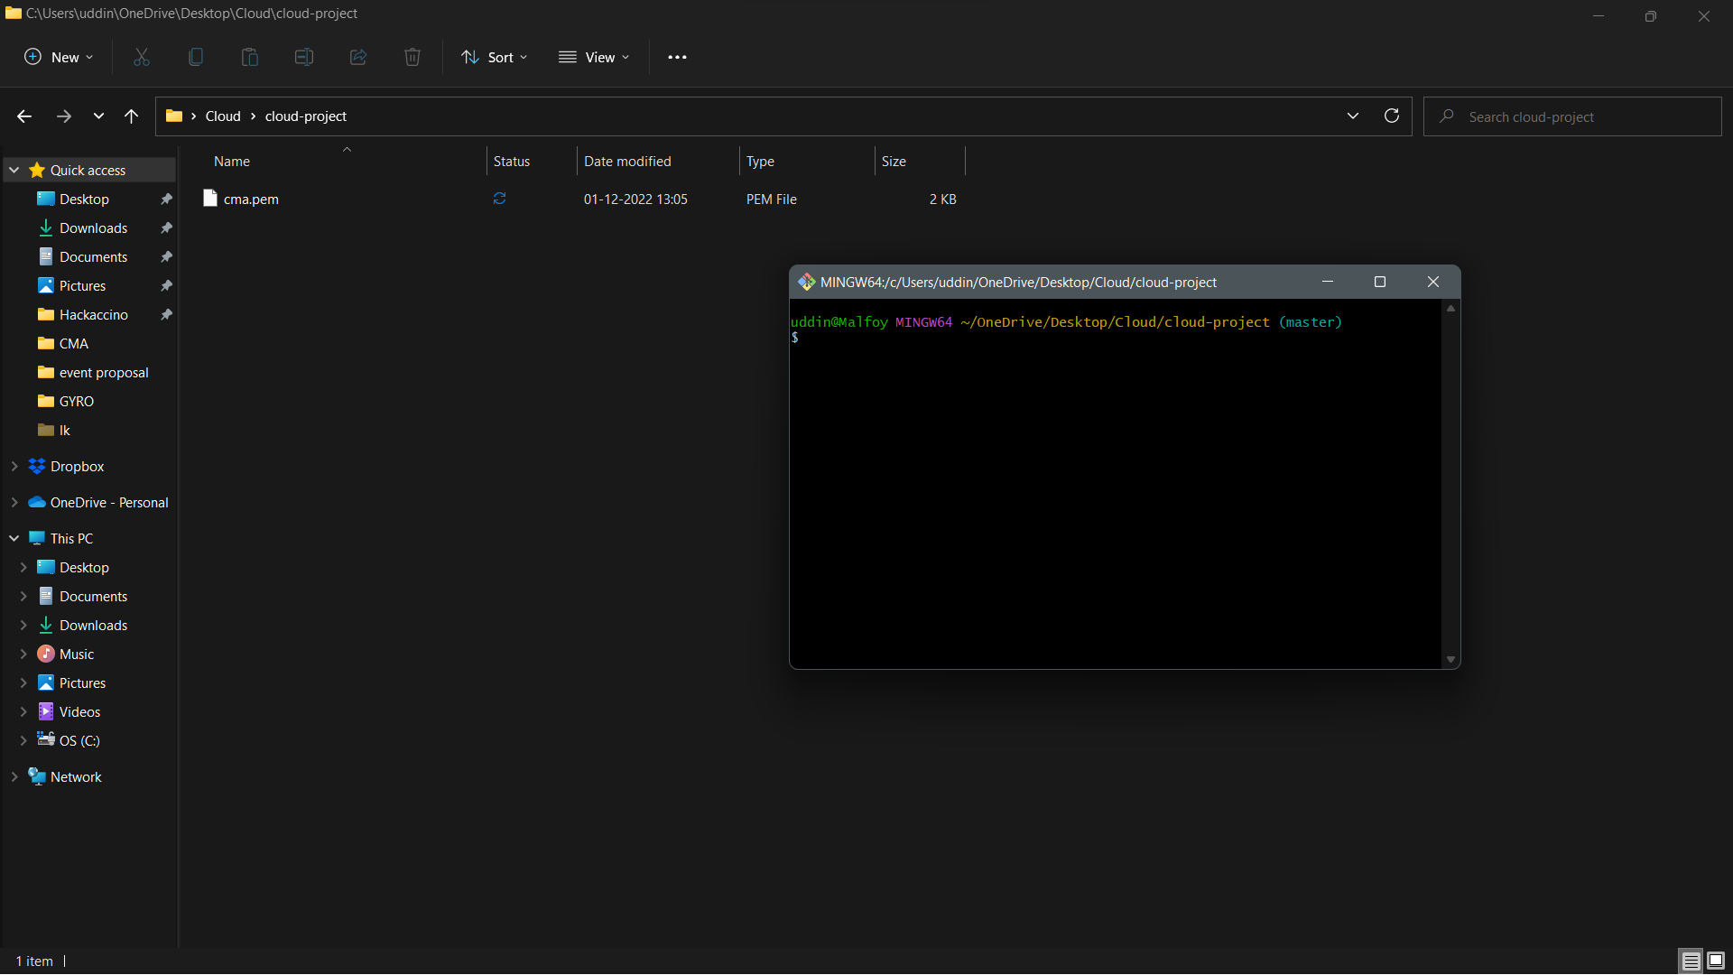

External URL of the webapp created

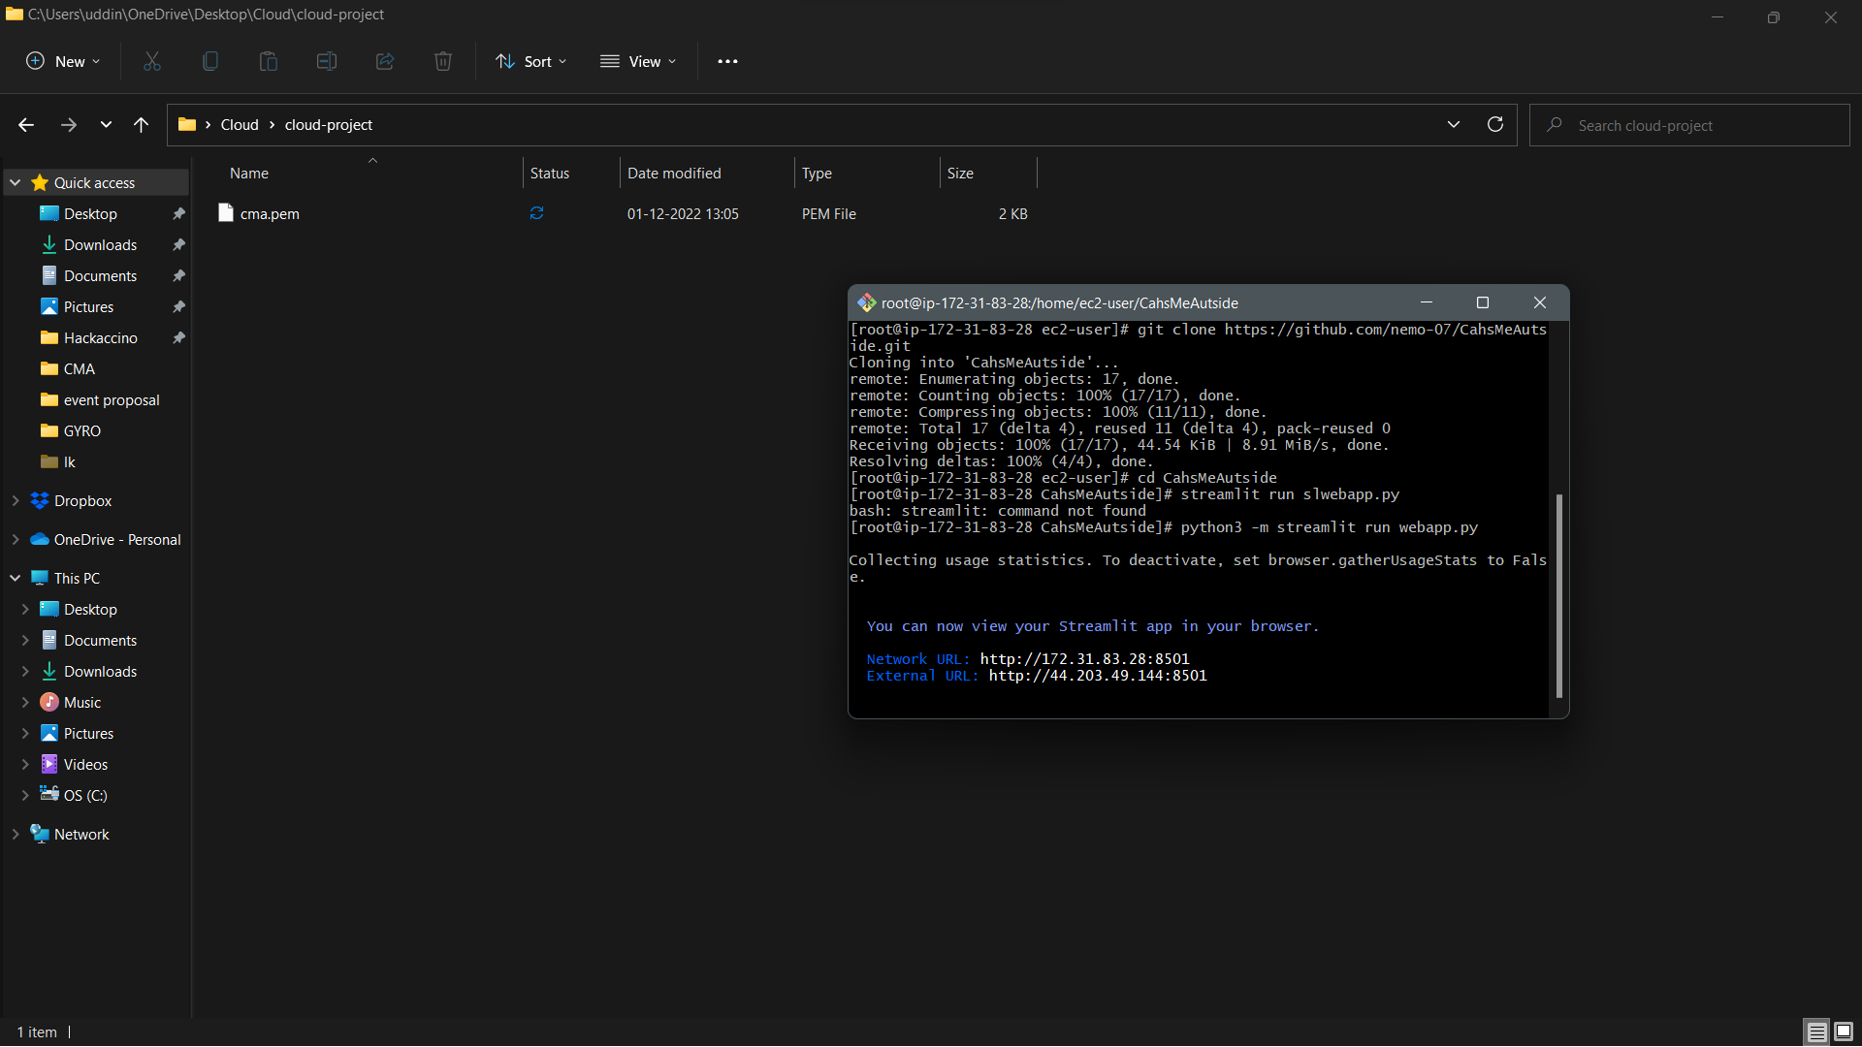  
Web app working successfully

